Programming with C Language
Tutorial 07 – Functions in C Language

- Write a function that will read 2 numbers and calculate and display sum and difference.
- No return type,no parameters

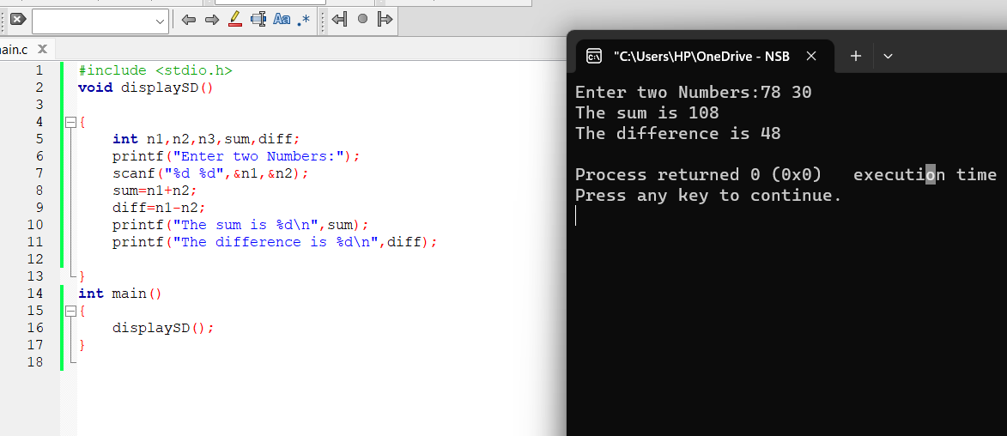
- Write a function that accepts 2 numbers as parameters and calculate and display sum and difference.
- No return,with parameters
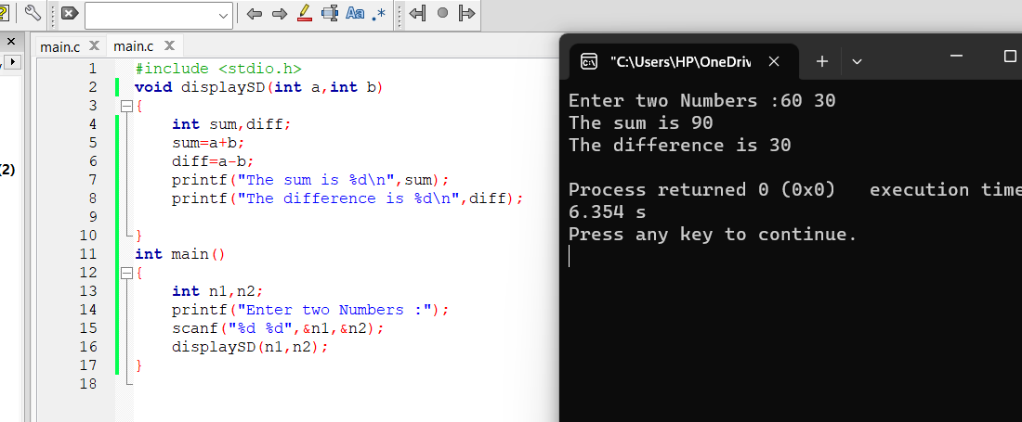

- Write a function that accepts 2 whole numbers as parameters and calculate and return the product.
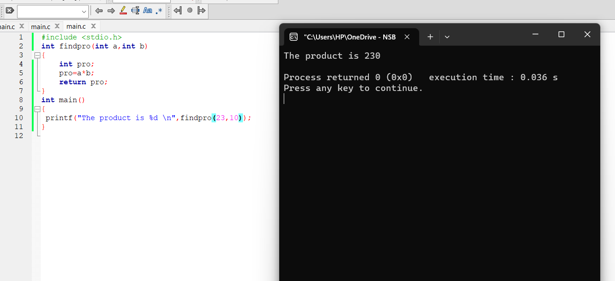

- Write a function that accepts 2 whole numbers as parameters and calculate and return the quotient.
- Write a function to read 2 numbers and display the sum. Call this function from the main function several times.
- Write a function which accepts 2 integers as parameters and display the sum, difference and product using a single printf statement.
- Write a function which accepts an integer and a float value as parameters and return the product as a double value. Display the result from the main function.
- Give the function header for each of the following functions.
  - Function hypotenuse that takes two double-precision floating-point arguments, side1 and side2, and returns a double-precision floating-point result.
  - Function smallest that takes three integers, x, y, z, and returns an integer.
  - Function instructions that does not receive any arguments and does not return a value.
[Note: Such functions are commonly used to display instructions to a user.]
  - Function intToFloat that takes an integer argument, number, and returns a floatingpoint result.

